A short report documenting the steps you took to deploy your WordPress website on AWS.
- Create an EC2 instance.
- Assign the instance an Elastic IP Address
- Use either terminal or MobaXterm to connect to your instance using the Public IP address of that instance.
When connected, use the following commands to setup your wordpress website:
- Install Apache server on Ubuntu.
  - sudo apt install apache2
- Install php runtime and php mysql connector.
  - sudo apt install php libapache2-mod-php php-mysql
- Install MySQL server.
  - sudo apt install mysql-server
- MYSQL SETUP:
  - Login to MySQL server
    - sudo mysql -u root
  - Change authentication plugin to mysql_native_password (change the password to something strong)
    - ALTER USER 'root'@'localhost' IDENTIFIED WITH mysql_native_password by 'Testpassword@123';
  - Create a new database user for wordpress (change the password to something strong)
    - CREATE USER 'wp_user'@localhost IDENTIFIED BY 'Testpassword@123';
  - Create a database for wordpress
    - CREATE DATABASE wp;
  - Grant all privilges on the database 'wp' to the newly created user
    - GRANT ALL PRIVILEGES ON wp.* TO 'wp_user'@localhost;
- Download WordPress.
  - cd /tmp
  - wget https://wordpress.org/latest.tar.gz
- Unzip.
  - tar -xvf latest.tar.gz
- Move WordPress folder to Apache document root.
  - sudo mv wordpress/ /var/www/html
- After that go to the link.
  - <your public ip address>/wordpress
- It will ask you for the database details.
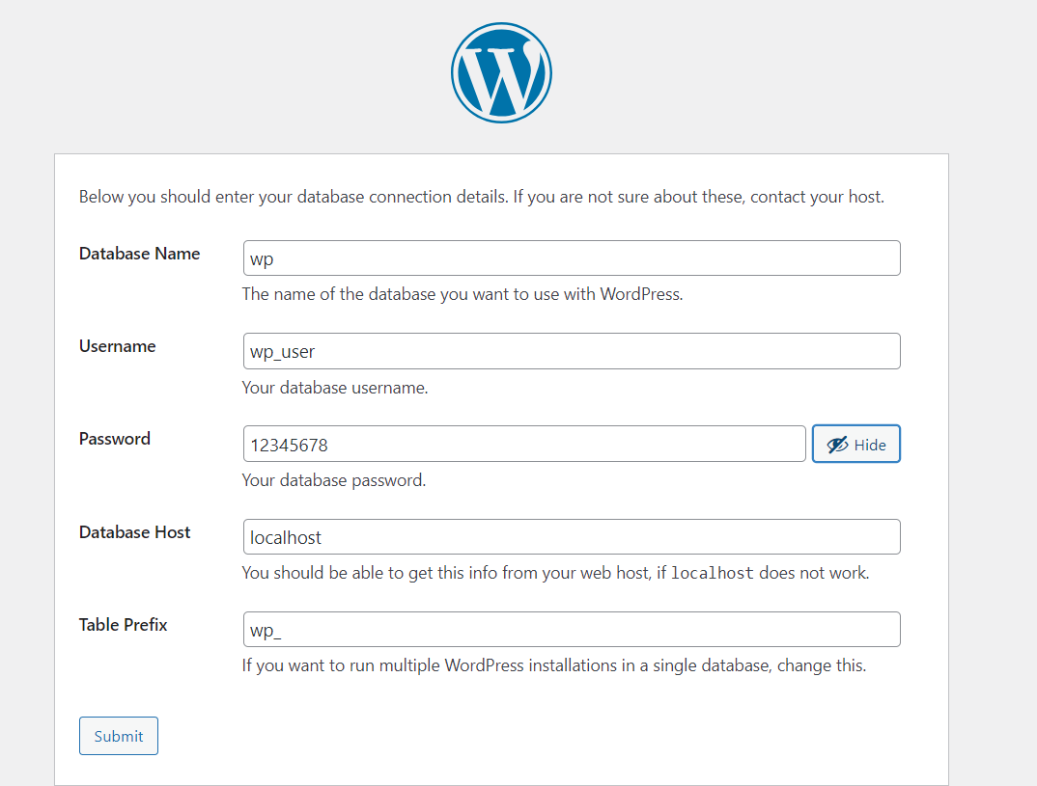
- This will give you php code for wp-config file.
- Go back to the terminal connected to your instance and run the following commands.
  - cd /var/www/html/wordpress/
  - nano wp-config.php
- Paste the code in it and Refresh the site. It will ask for information about the site.
- Set it up according to your liking.
- You will the wordpress website up and running on your instance.
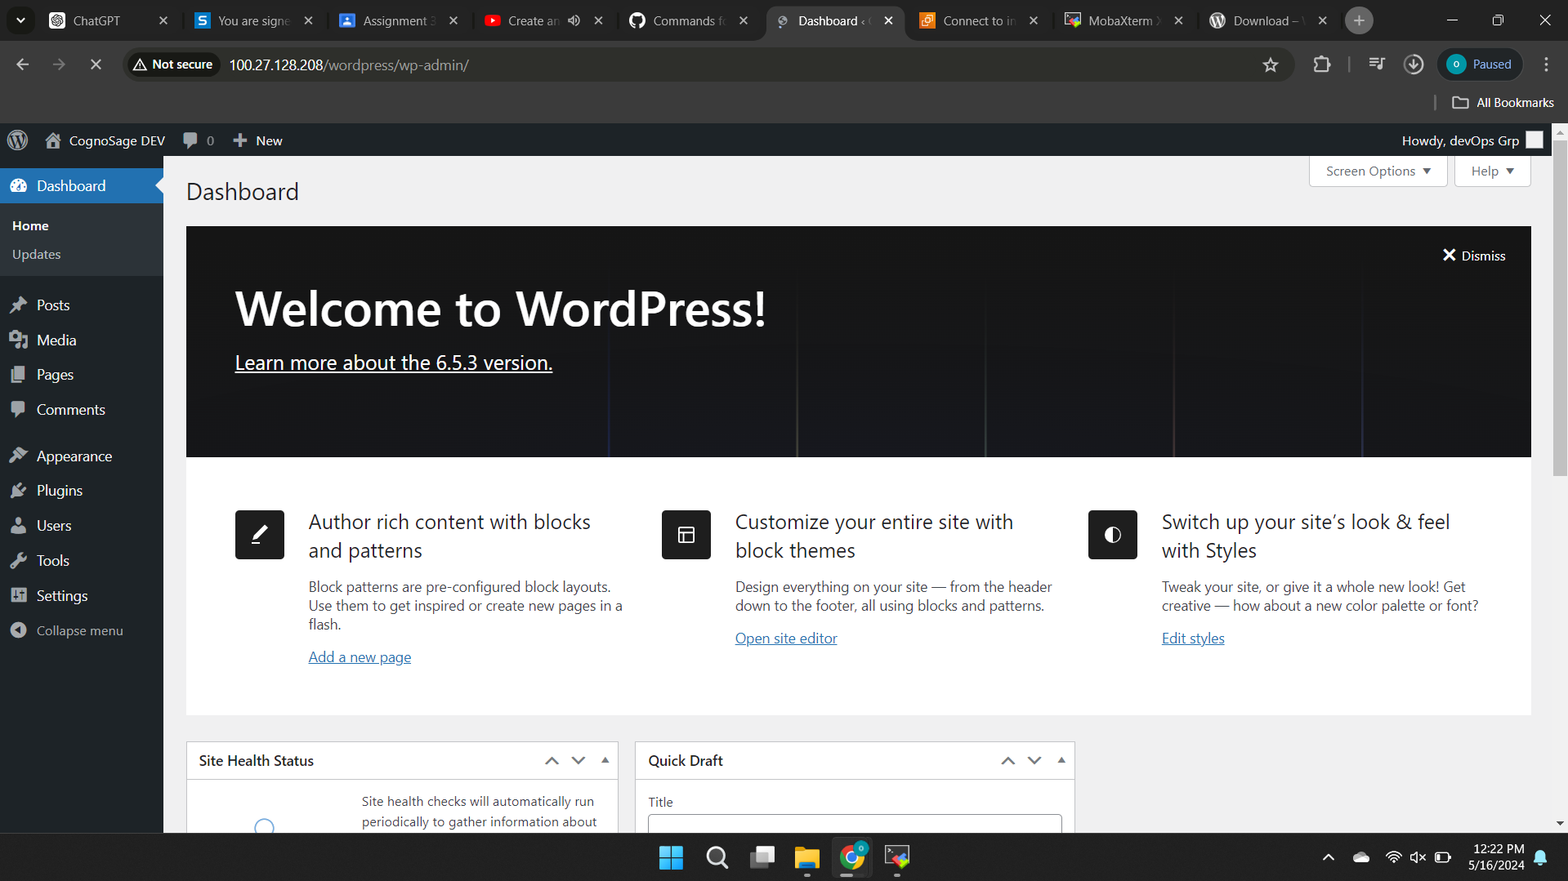
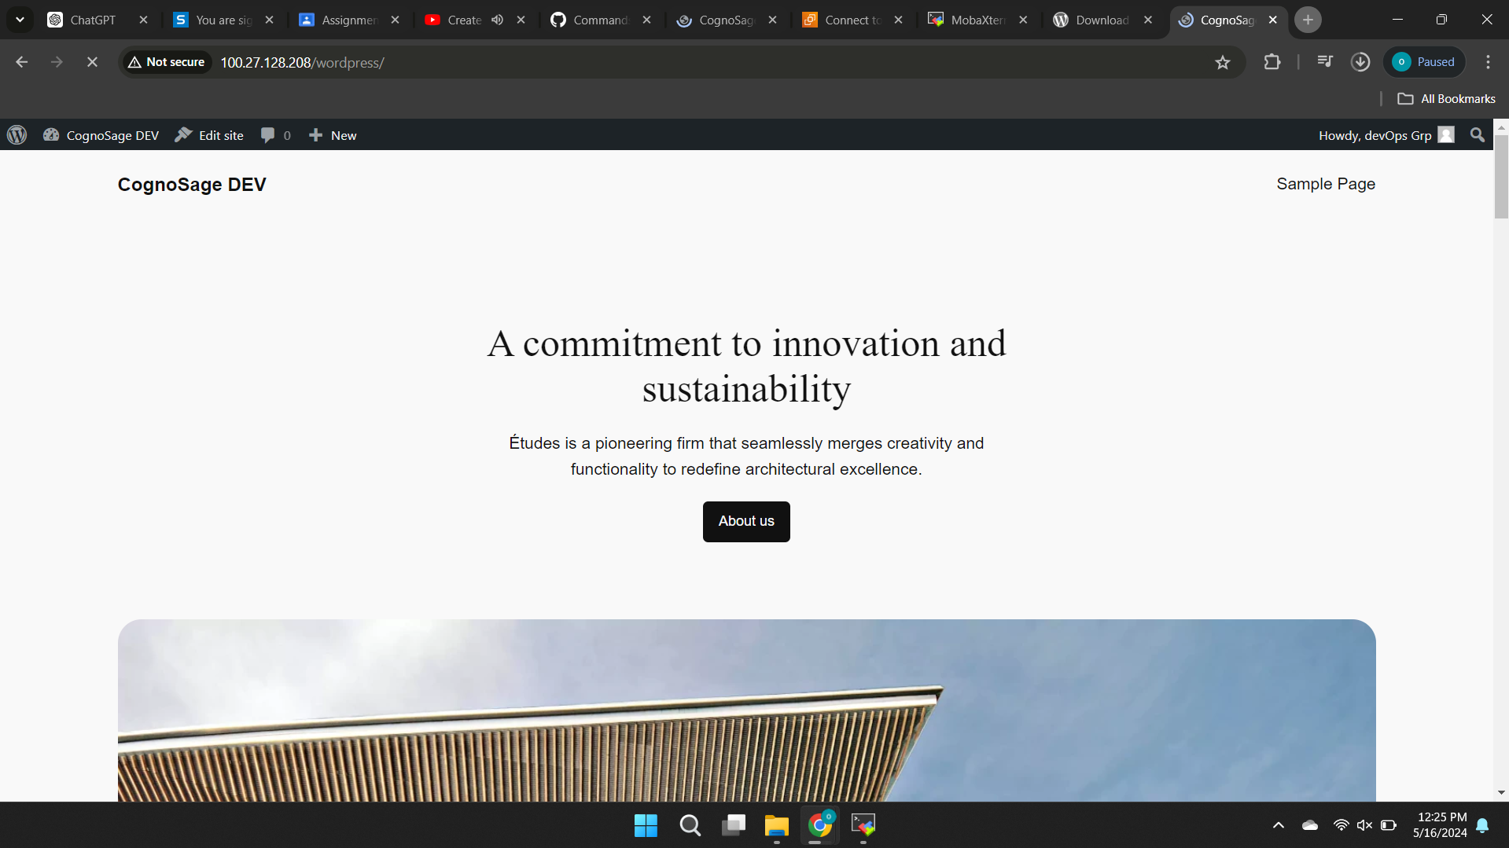

Public/External IP address on which our website is deployed:
http://100.27.128.208/wordpress/

